CAPTURE AMAGANSETT
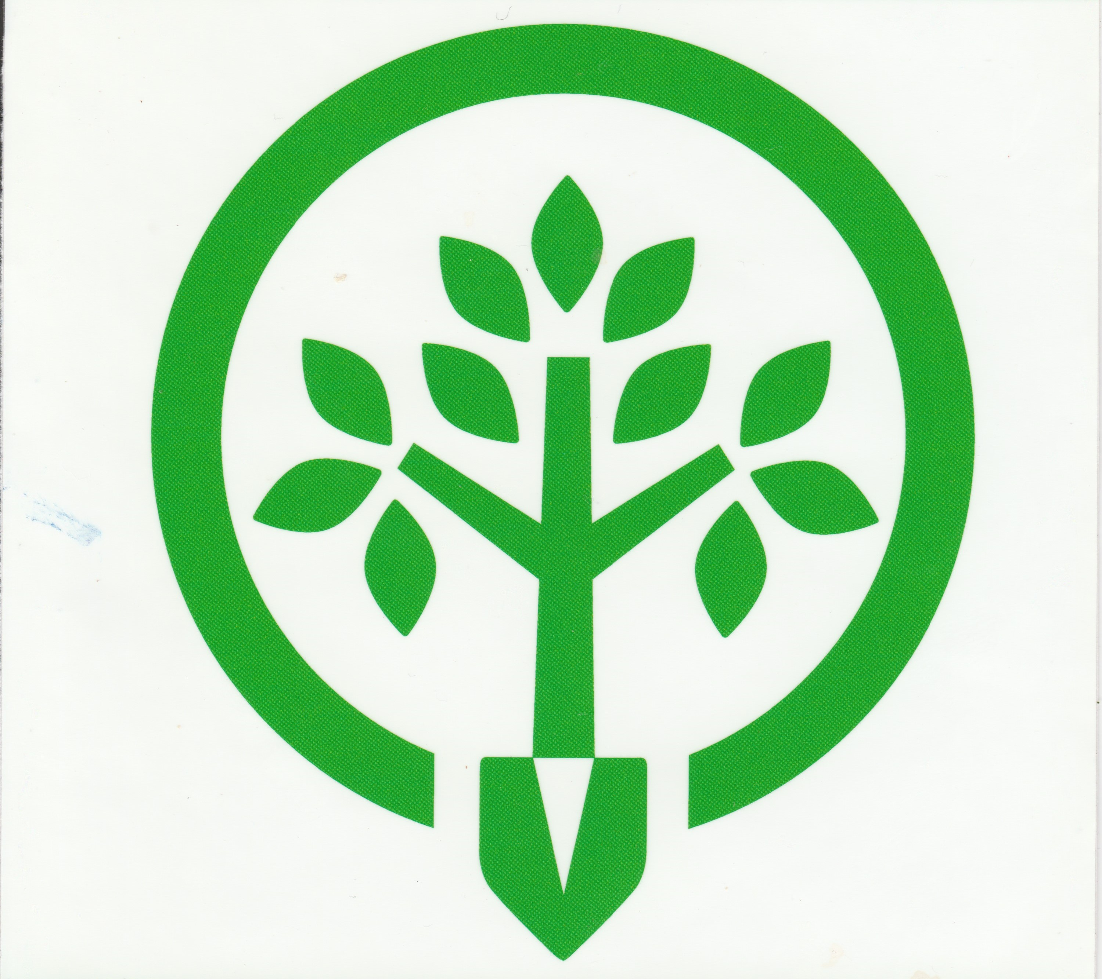

2022 Photo Contest Entry Form

Name

Address

City State Zip Code

Daytime Phone Email

Photo Details

Title

Category

☐ Amagansett Native & Wildlife ☐ Amagansett Landmarks

☐ Amagansett Community ☐ Amagansett by the Water

Location photo was taken

I certify that I have read and understand the rules of the contest posted on the A.V.I.S. website. I agree to allow the Amagansett Village Improvement Society to publish my photo in print or use electronically. If I am a winner, I also give the Amagansett Village Improvement Society permission to publicize my name and share the phone number and email address provided above with members of the media who request it.

Signature

Signature of parent/guardian (required if under 18)

Please download, fill out and email this form along with your photograph to info@amagansettavis.com no later than Sunday, April 24, 2022

